**AirSafety Project PowerBI**

Air travel has emerged as the most efficient and widely utilized form of transportation globally, facilitating the connection of individuals and goods across the globe. Nonetheless, with the escalating number of passengers and flight routes, ensuring safety has become increasingly crucial. This project seeks to investigate statistical data pertaining to airplane accidents that took place between 2000 and 2009, with the goal of analyzing multiple factors. These factors encompass accident locations, fatalities attributed to operators, yearly accident rates, engine types, and aircraft model incidents. By examining these variables, valuable insights can be obtained regarding the primary contributors to the highest percentage of accidents. This analysis can serve as an initial step towards conducting further research to pinpoint the fundamental causes of accidents, subsequently aiding in the prevention of such incidents and bolstering aviation safety.

**Contents**

**Project Overview**

**Problem Statement**

**KPI and Data Dictionary**

**Executive Summary and the problems that occurred during the project.**

**Key Insights**

**Recommendations**

**Deployment**

**Project Overview**

Airplanes have become the predominant and highly efficient means of transportation, facilitating global connectivity for both people and cargo. However, with the continuous growth in passenger numbers and flight routes, ensuring safety has become increasingly imperative. This project aims to scrutinize statistical data in the field of aviation, specifically focusing on airplane accidents that took place between 2000 and 2009. By analyzing various factors including accident locations, operator-related fatalities, accident frequency over the years, engine types, and aircraft models involved in accidents, the objective is to gain valuable insights into the leading causes of accidents. This analysis will lay the groundwork for further research endeavors, aiming to identify the underlying reasons behind these accidents and implement preventive measures to enhance aviation safety in the future**.**

**Problem Statement**

The aviation industry has consistently faced challenges regarding air safety, primarily attributable to factors such as inadequate training, pilots failing to meet flight simulator training hour requirements, and the adverse impact of prolonged flying on pilots' physical and emotional well-being, leading to reduced time spent with their families. According to the National Transportation Safety Board, there have been 3,941 fatal accidents during landing, resulting in over 20,000 fatalities over the years. The truth remains that as long as airplanes continue to take flight, air accidents will persist as a significant concern within the broader context of air safety.



**KPIs**

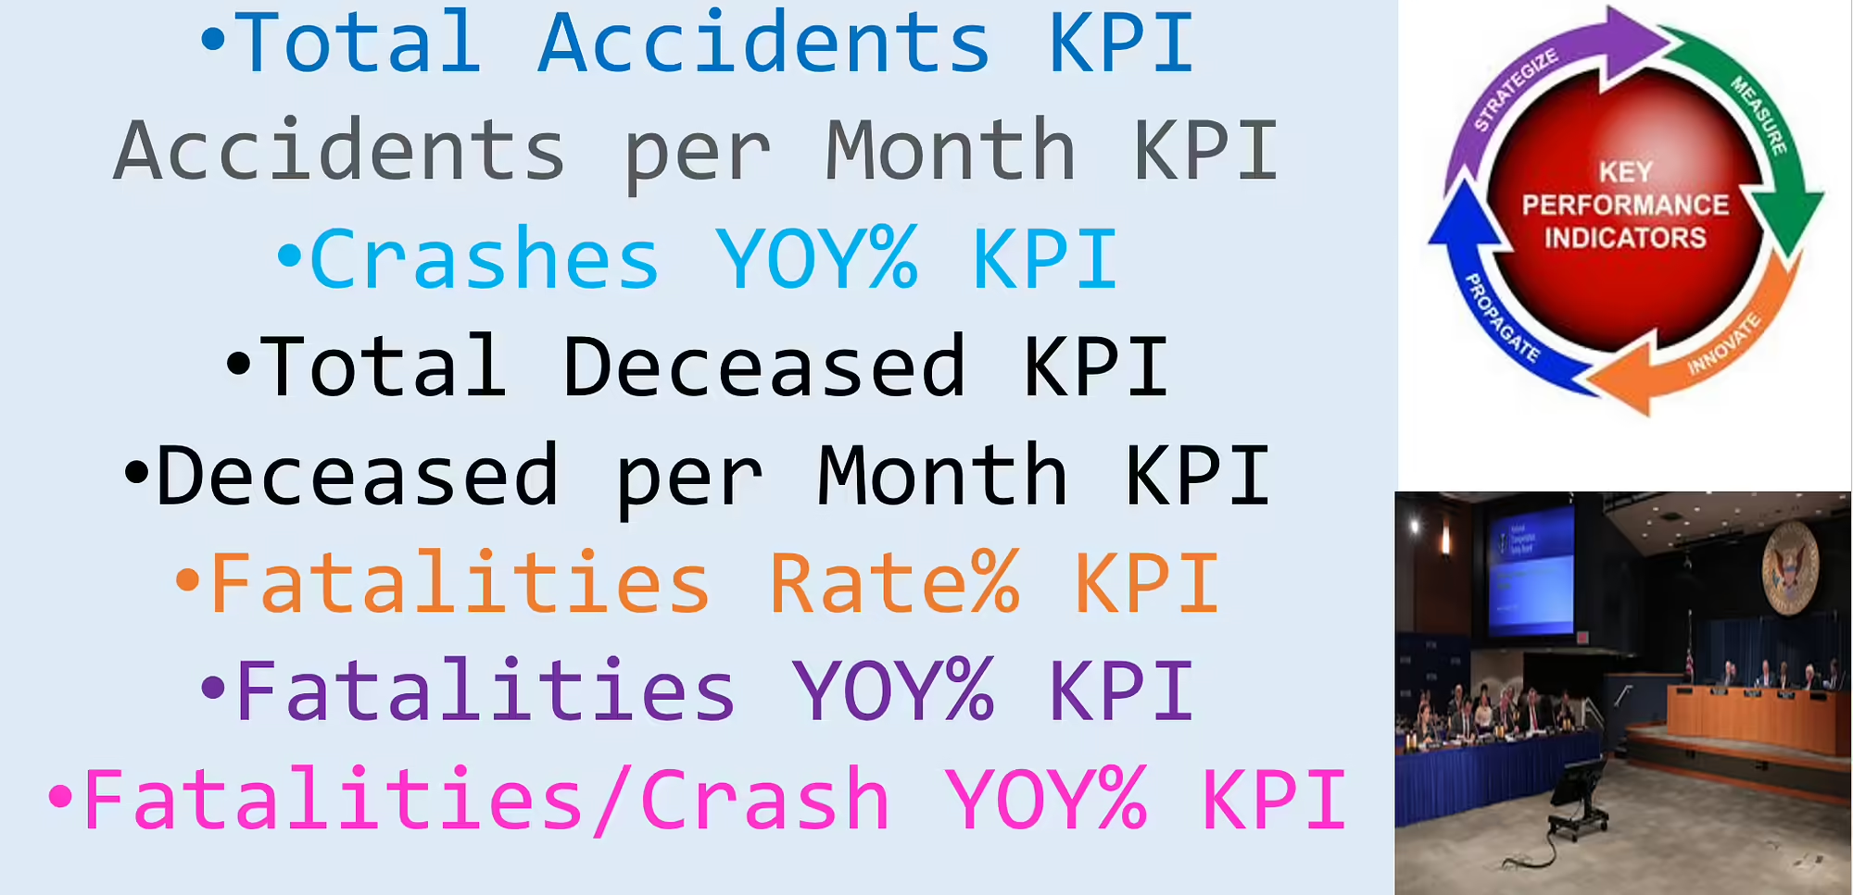

| **% Previous YOY Crashes = DIVIDE([Previous Year Crashes]- [Previous Previous Year Crashes],[Previous Previous Year Crashes],0)** |
| --- |
| **% YOY Crashes = DIVIDE([Total Crashes]-[Previous Year Crashes],[Previous Year Crashes],0)** |
| **% YOY Deceased = DIVIDE([Total Deceased]-[Previous Year Deceased],[Previous Year Deceased],0)** |
| **% YOY Fatalities Per Crash = DIVIDE([Fatalities Per Crash]-[Previous Year Fatalities Per Crash],[Previous Year Fatalities Per Crash],0)** |
| **Crashes Arrow =**  **VAR currentValue = [Total Crashes] // Replace [YourMeasure] with your actual measure name**  **VAR previousValue = [Previous Year Crashes]**  **RETURN**  **IF(ISBLANK(currentValue),**  **".",**  **IF(currentValue > previousValue,**  **UNICHAR(9650), // Up arrow Unicode character**  **IF(currentValue < previousValue,**  **UNICHAR(9660), // Down arrow Unicode character**  **"."**  **)**  **)**  **)** |
| **Crashes ColorByIncreaseDecrease =**  **VAR currentValue = [Total Crashes] -- Replace [YourMeasure] with your actual measure name**  **VAR previousValue = [Previous Year Crashes]**  **RETURN**  **IF(ISBLANK(currentValue) ,**  **BLANK(),**  **IF(currentValue > previousValue,**  **"Red", -- Set the color to green if the current value is greater than the previous value**  **IF(currentValue < previousValue,**  **"Green", -- Set the color to red if the current value is less than the previous value**  **"Black" -- Set a default color if the values are equal**  **)**  **)**  **)** |
| **Crashes Per Month = DIVIDE([Total Crashes],DISTINCTCOUNT('Calendar Lookup'[Start Of Month]))** |
| **Deceased Arrow =**  **VAR currentValue = [Total Deceased] // Replace [YourMeasure] with your actual measure name**  **VAR previousValue = [Previous Year Deceased]**  **RETURN**  **IF(ISBLANK(currentValue),**  **".",**  **IF(currentValue > previousValue,**  **UNICHAR(9650), // Up arrow Unicode character**  **IF(currentValue < previousValue,**  **UNICHAR(9660), // Down arrow Unicode character**  **"."**  **)**  **)**  **)** |
| **Deceased ColorByIncreaseDecrease =**  **VAR currentValue = [Total Deceased] -- Replace [YourMeasure] with your actual measure name**  **VAR previousValue = [Previous Year Deceased]**  **RETURN**  **IF(ISBLANK(currentValue) ,**  **BLANK(),**  **IF(currentValue > previousValue,**  **"Red", -- Set the color to green if the current value is greater than the previous value**  **IF(currentValue < previousValue,**  **"Green", -- Set the color to red if the current value is less than the previous value**  **"Black" -- Set a default color if the values are equal**  **)**  **)**  **)** |
| **Fatalities Per Crash = DIVIDE([Total Deceased],[Total Crashes],0)** |
| **Fatalities Per Month = DIVIDE([Total Deceased],DISTINCTCOUNT('Calendar Lookup'[Start Of Month]))** |
| **Fatality Per Crash Arrow =**  **VAR currentValue = [% YOY Fatalities Per Crash] // Replace [YourMeasure] with your actual measure name**  **VAR previousValue = 0**  **RETURN**  **IF(ISBLANK(currentValue),**  **".",**  **IF(currentValue > previousValue,**  **UNICHAR(9650), // Up arrow Unicode character**  **IF(currentValue < previousValue,**  **UNICHAR(9660), // Down arrow Unicode character**  **"."**  **)**  **)**  **)** |
| **Fatality Per Crash ColorByIncreaseDecrease =**  **VAR currentValue = [% YOY Fatalities Per Crash] -- Replace [YourMeasure] with your actual measure name**  **VAR previousValue = 0**  **RETURN**  **IF(ISBLANK(currentValue) ,**  **BLANK(),**  **IF(currentValue > previousValue,**  **"Red", -- Set the color to green if the current value is greater than the previous value**  **IF(currentValue < previousValue,**  **"Green", -- Set the color to red if the current value is less than the previous value**  **"Black" -- Set a default color if the values are equal**  **)**  **)**  **)** |
| **Fatality Rate = DIVIDE([Total Deceased],[Total Aboard],0)** |
| **Fatality Rate Arrow =**  **VAR currentValue = [Fatality Rate] // Replace [YourMeasure] with your actual measure name**  **VAR previousValue = [Previous Year Fatality Rate]**  **RETURN**  **IF(ISBLANK(currentValue),**  **".",**  **IF(currentValue > previousValue,**  **UNICHAR(9650), // Up arrow Unicode character**  **IF(currentValue < previousValue,**  **UNICHAR(9660), // Down arrow Unicode character**  **"."**  **)**  **)**  **)** |
| **Fatality rate ColorByIncreaseDecrease =**  **VAR currentValue = [Fatality Rate] -- Replace [YourMeasure] with your actual measure name**  **RETURN**  **IF(ISBLANK(currentValue) ,**  **BLANK(),**  **IF(currentValue > 0,**  **"Red", -- Set the color to green if the current value is greater than the previous value**  **IF(currentValue < 0,**  **"Green", -- Set the color to red if the current value is less than the previous value**  **"Black" -- Set a default color if the values are equal**  **)**  **)**  **)** |
| **MTD Crashes = CALCULATE([Total Crashes],DATESMTD('Calendar Lookup'[Date]))** |
| **Previous Previous Year Crashes = CALCULATE([Total Crashes],DATEADD('Calendar Lookup'[Date],-2,YEAR))** |
| **Previous Year Aboard = CALCULATE([Total Aboard],DATEADD('Calendar Lookup'[START OF YEAR],-1,YEAR))** |
| **Previous Year Crashes = CALCULATE([Total Crashes],DATEADD('Calendar Lookup'[Date],-1,YEAR))** |
| **Previous Year Deceased = CALCULATE([Total Deceased],DATEADD('Calendar Lookup'[START OF YEAR],-1,YEAR))** |
| **Previous Year Fatalities Per Crash = CALCULATE([Fatalities Per Crash],DATEADD('Calendar Lookup'[Date],-1,YEAR))** |
| **Previous Year Fatality Rate = DIVIDE([Previous Year Deceased],[Previous Year Aboard],0)** |
| **Total Aboard = SUM(AirSafety[Aboard])** |
| **Total Alive = [Total Aboard] - [Total Deceased]** |
| **Total Crashes = COUNTROWS(AirSafety)** |
| **Total Deceased = SUM(AirSafety[Fatalities])** |
| **YTD Crashes = CALCULATE([Total Crashes],DATESYTD('Calendar Lookup'[Date]))** |

**Data Dictionary**

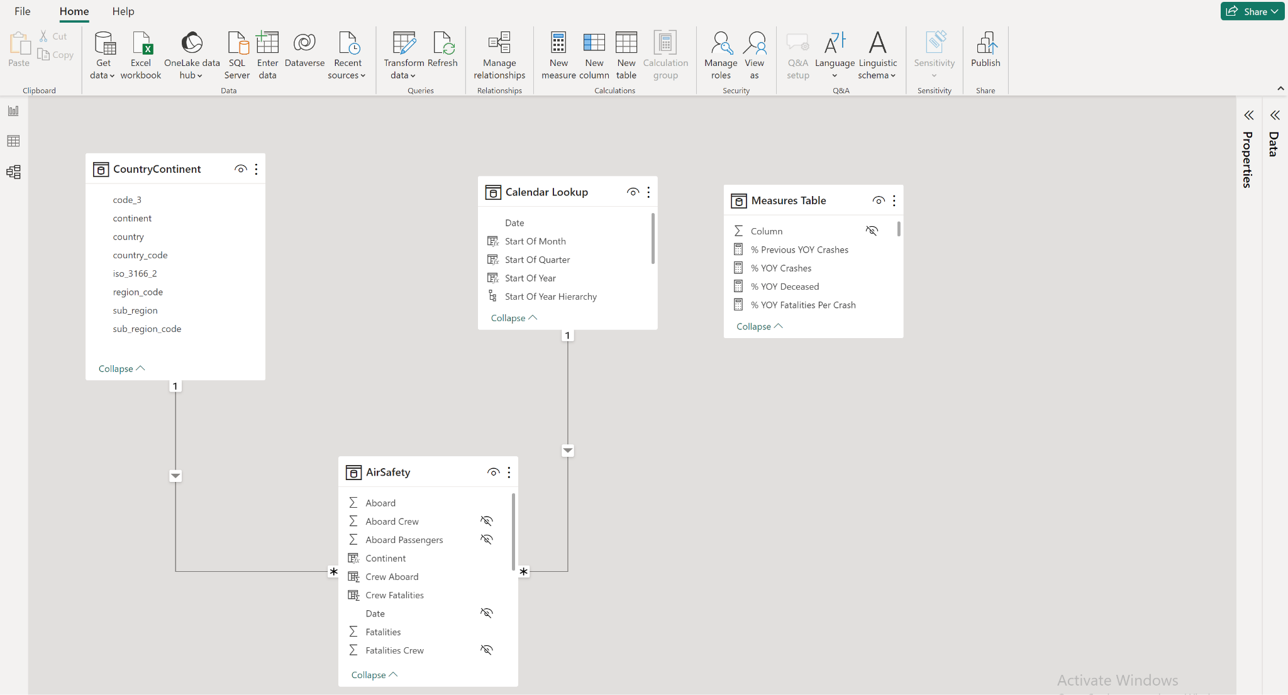

**Executive Summary**

**Challenges Encountered**

1. The selection of an appropriate dataset posed a significant challenge during the project.

2. The dataset contained numerous calculation errors, requiring thorough identification and resolution to ensure accurate visualization of key performance indicators (KPIs) and visuals. Data cleaning was performed at both the source level and during Power BI's data transformation process. Additionally, missing data needed to be addressed before completing the data analysis.

3. Creating videos and using ShareX to generate gifs presented a new and unfamiliar task, requiring additional effort and learning.

4. The initial plotting of accident locations revealed inaccuracies, necessitating the rewriting of location data. The selection of a suitable map that accurately represented all accident locations became a critical step in the analysis process.

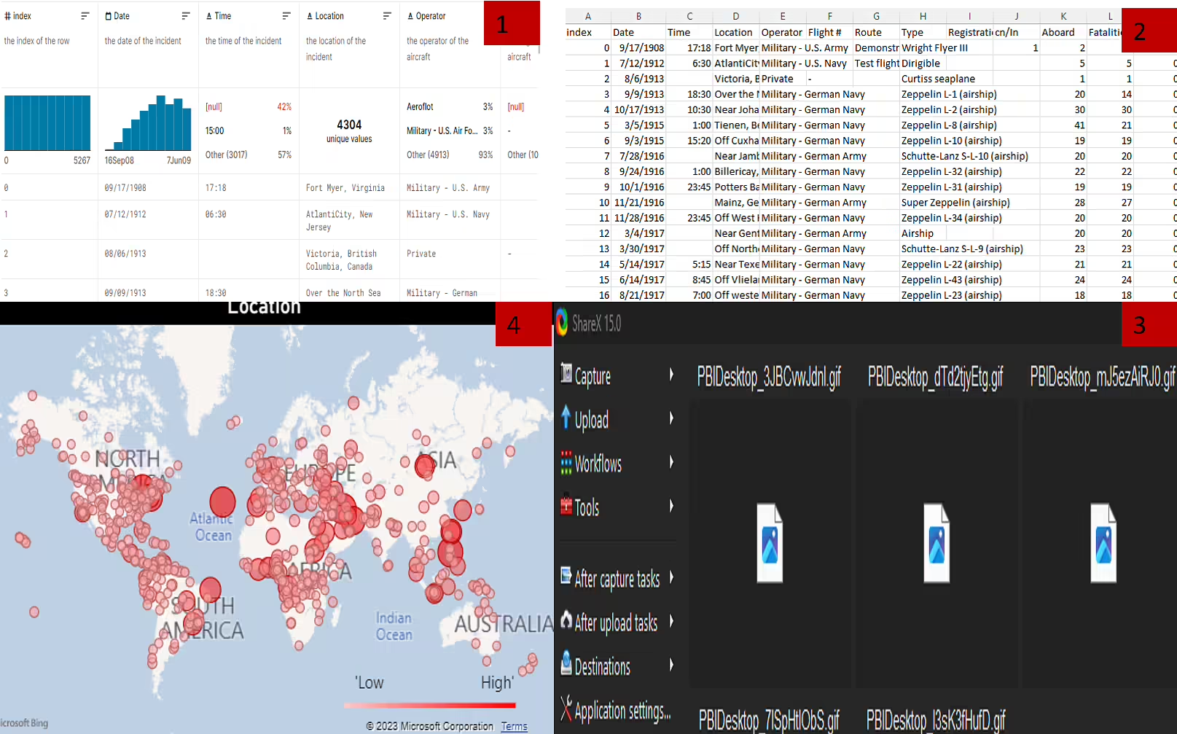

**Key Insights & Takeaways**

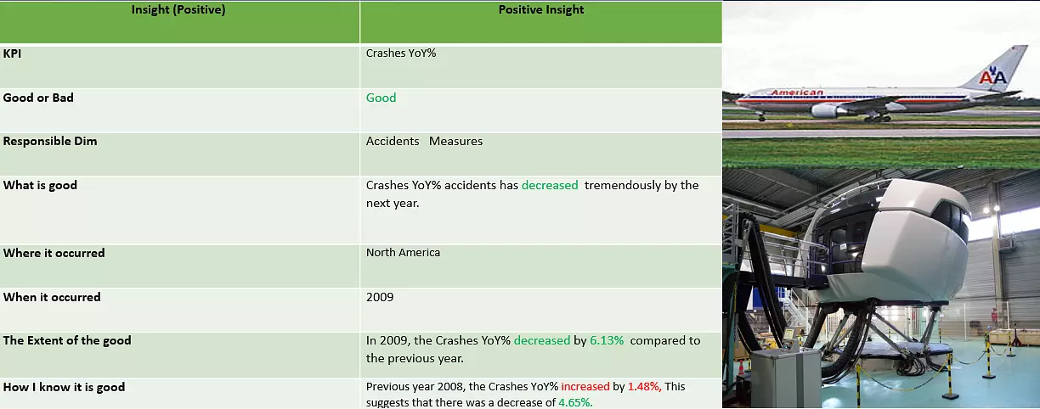

# The year-on-year percentage decrease in fatalities for accidents involving jet engines was 6.15% and 5.09% in 2003 compared to the preceding year, 2002. This indicates a cumulative decrease of 11.24%, reflecting a positive outcome in line with the suggested improvement.

# 

# **Deployment**

# 





